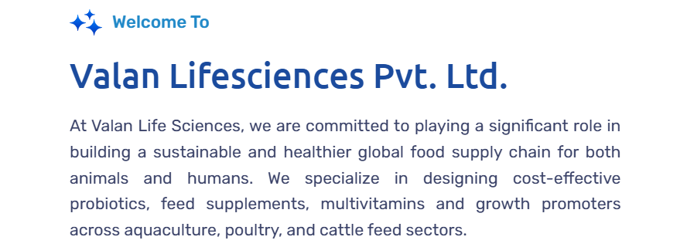

Note – company name should be Valan Life Sciences Pvt Ltd throughout ... spacing between Life and Science, please check this for all plages

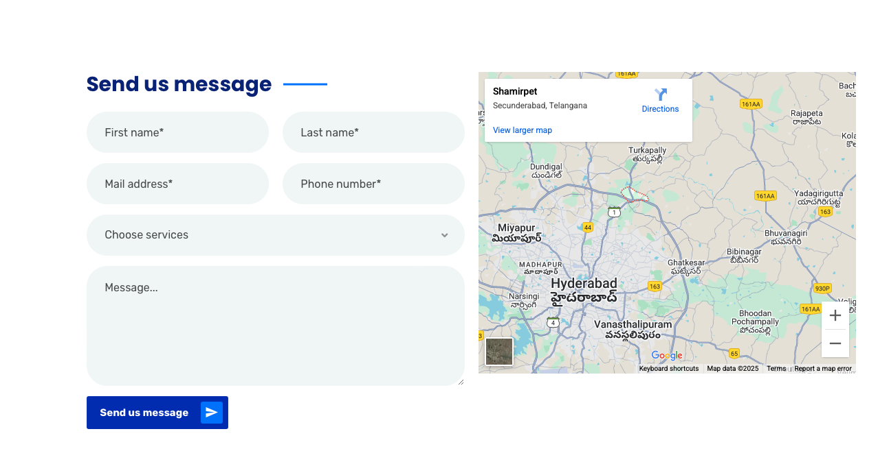

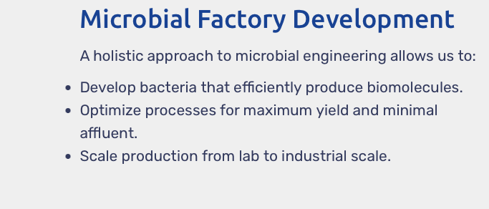







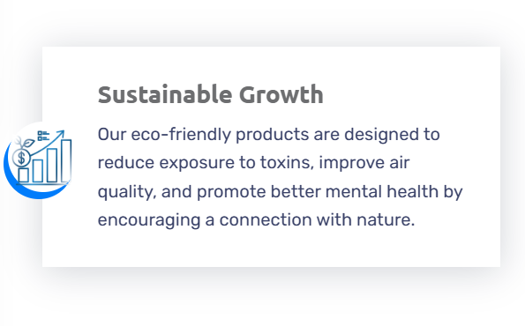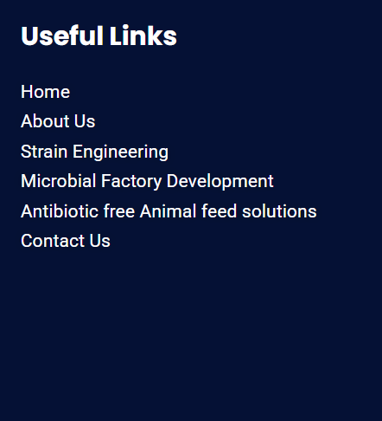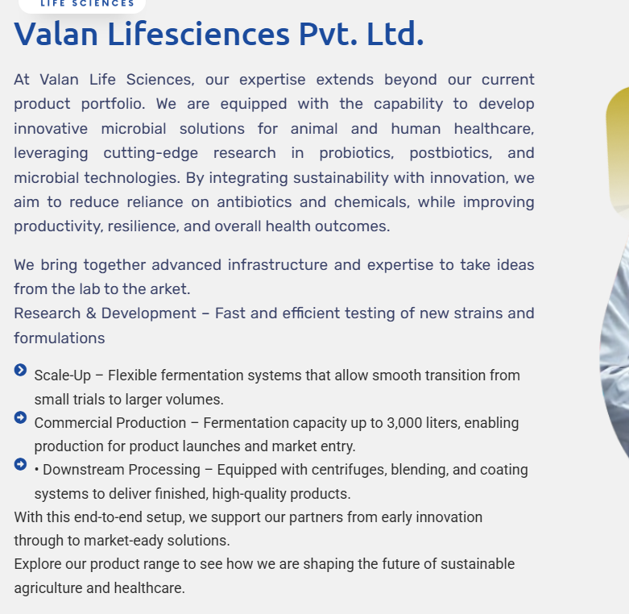

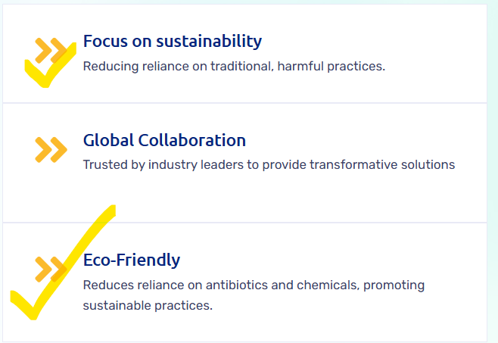

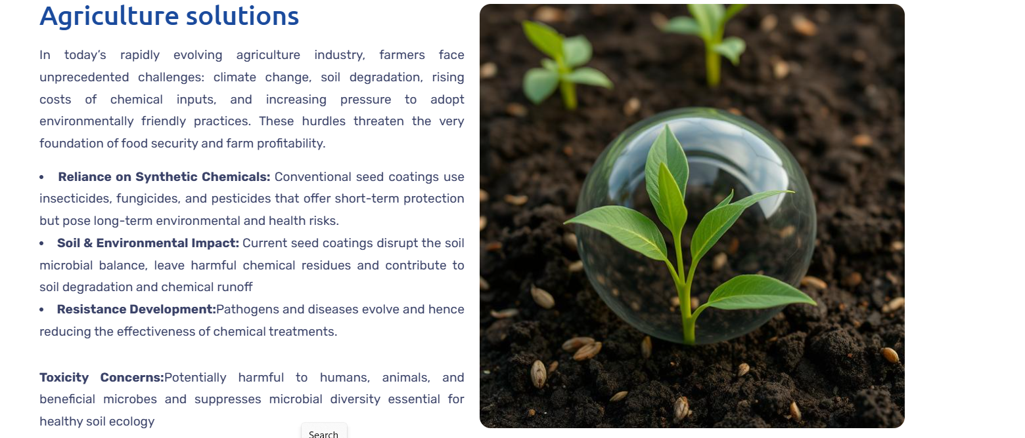

Overall – agriculture solutions page needs to be discussed on phone to rearrange the content ...

Herer is the link with updated brochure :- <https://drive.google.com/drive/folders/1AaNvjYK9ZEJR_vTm4JzAqkxy-CRAqI3E>

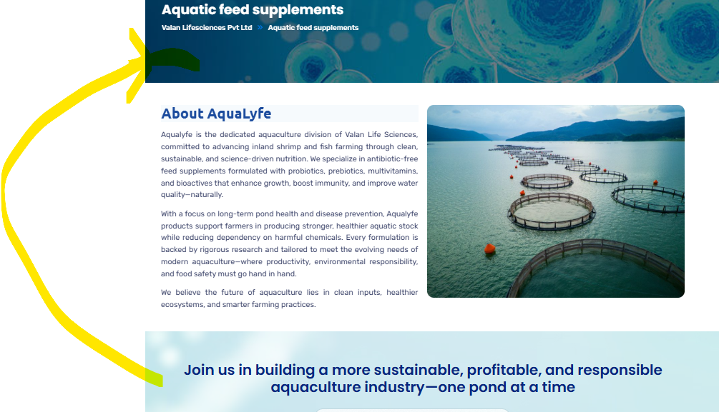

<https://wwwvalanlifesviencescom.odoo.com/>

<https://lorvenbiologics.com/>

<https://drive.google.com/drive/folders/1AaNvjYK9ZEJR_vTm4JzAqkxy-CRAqI3E?usp=sharing>

Link for agrovale